**1.Flexbox with Bootstrap:** Flexbox is a CSS layout module that allows responsive elements within a container to be automatically arranged depending upon screen size. Bootstrap 4 and 5 use Flexbox as their main layout system.

2. Flexbox Direction: You can change the direction of the flex items with flex-row (default), flex-row-reverse, flex-column, or flex-column-reverse.

3. Flexbox Align Items: You can align flex items along the vertical axis with align-items-start, align-items-end, align-items-centre, align-items-baseline, or align-items-stretch.

4. Flexbox Justify Content: You can justify the flex items along the horizontal axis with justify-content-start, justify-content-end, justify-content-canter, justify-content-between, or justify-content-around.

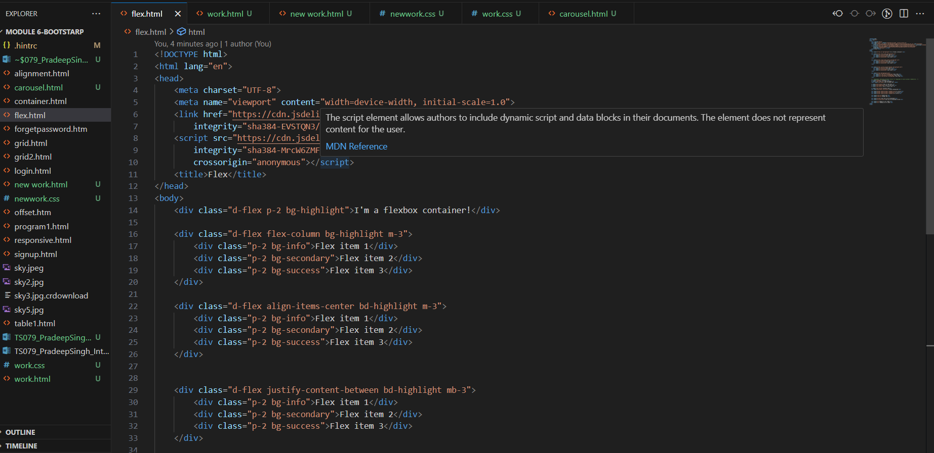

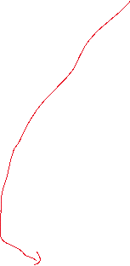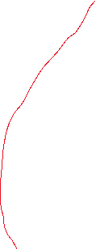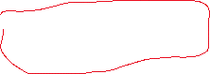

For above code below is the output:

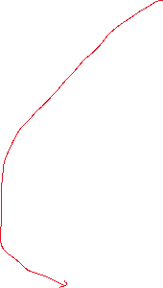

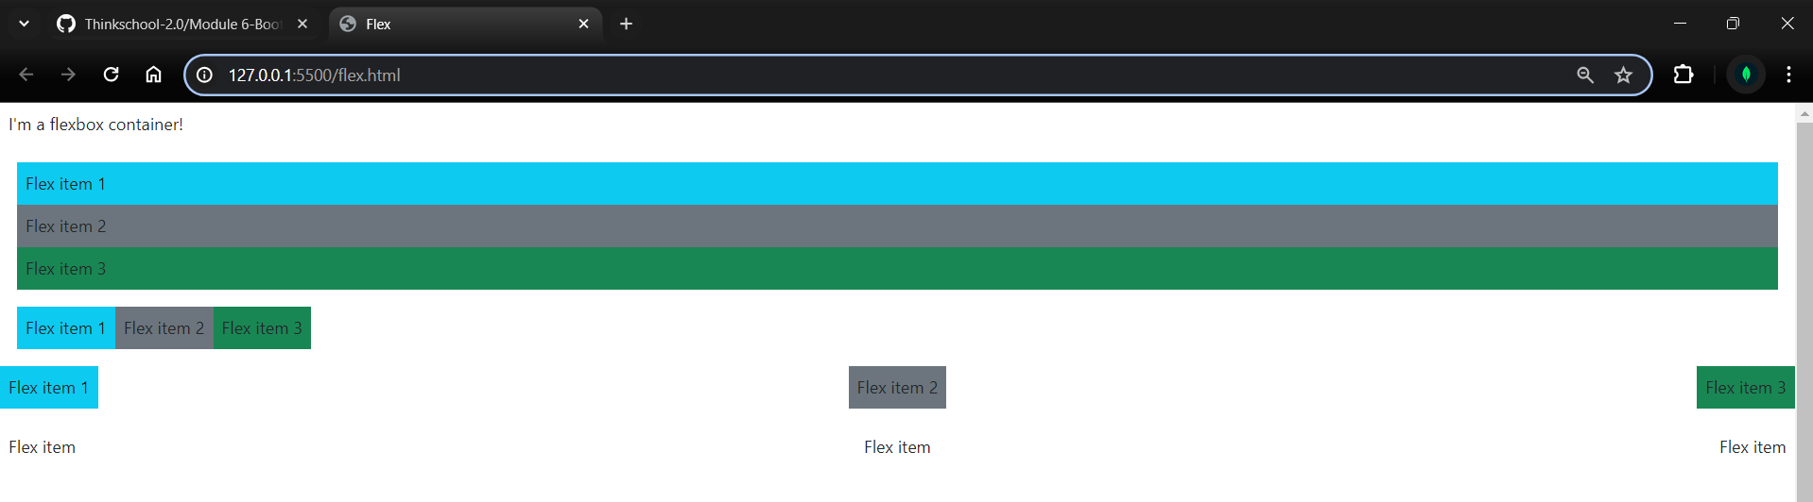

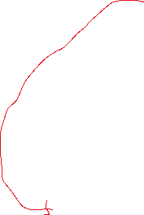

5. Flexbox Fill, Grow and Shrink: Use flex-fill, flex-grow-*, and flex-shrink-* to manipulate the sizes of flex items.

6. Typography: Default Font-Size: Bootstrap sets the default font-size to 16px, which is also the default size in most browsers. All the other typographic elements are sized relative to this.

7. PX, EM and REM Units: These are units in CSS. px is a fixed-size unit, em is relative to the font-size of its closest parent, and rem is relative to the font-size of the root element.

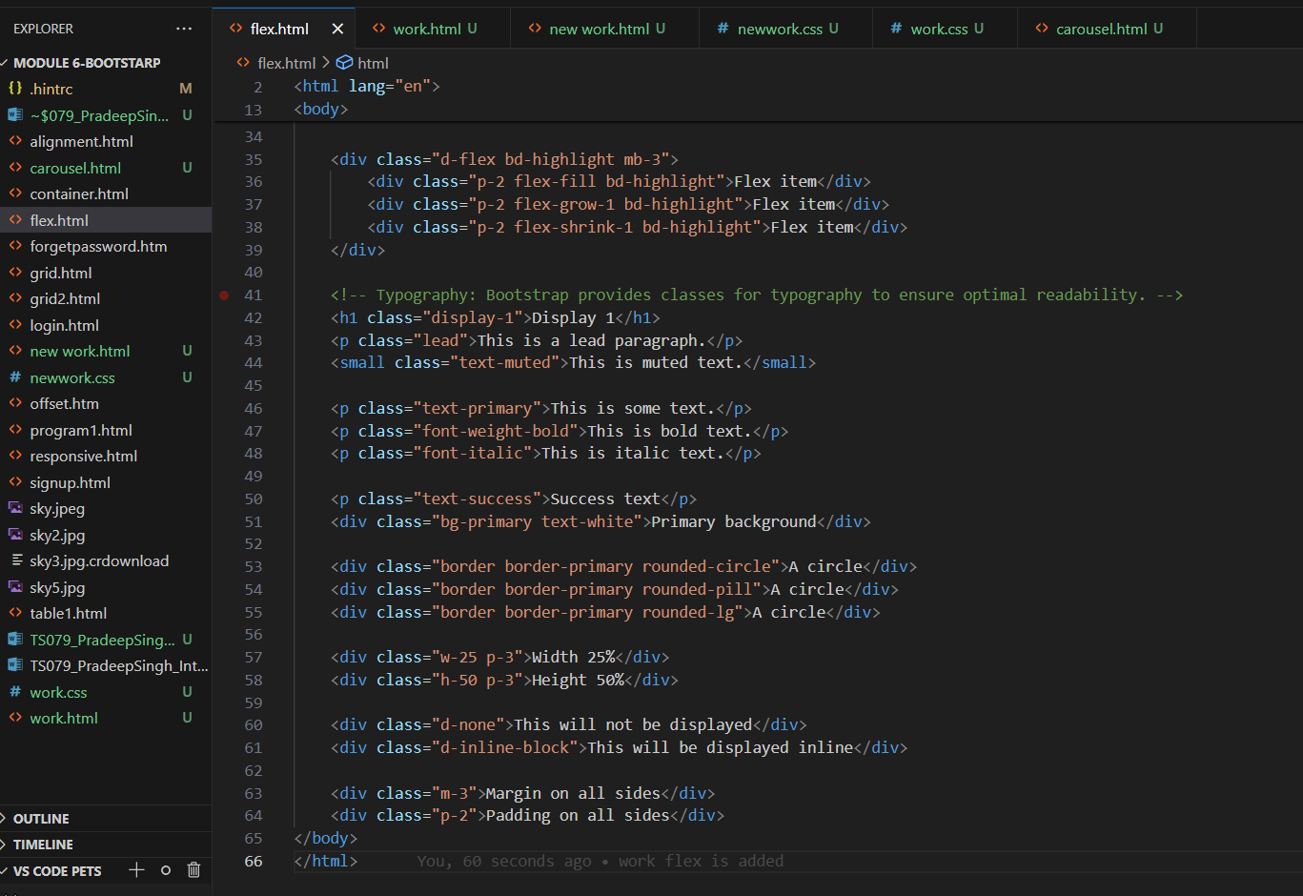

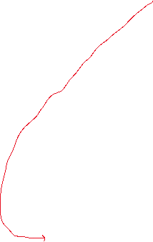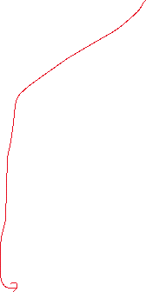

For above code below is the output on screen:

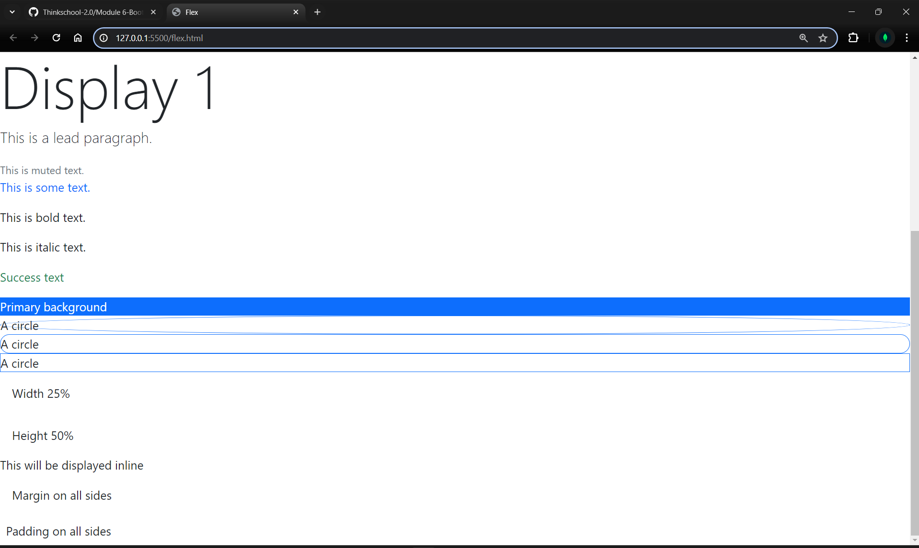

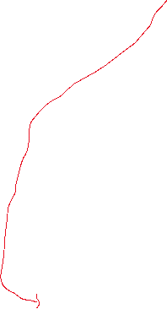

8. Text: Bootstrap provides several classes to style text, such as .text-left, .text-right, .text-canter, .text-justify, .text-lowercase, .text-uppercase, .text-capitalize, .font-weight-bold, .font-weight-normal, .font-italic, etc.

9. Colours: colours - Text Colours, Background colours: Bootstrap provides classes to colour text and backgrounds. For text colours, you can use .text-primary, .text-success, .text-info, .text-warning, .text-danger, .text-light, .text-dark, .text-body (default body colour/often black), .text-muted (Gray colour), and .text-white. For background colours, replace text with bg in the classes.

10. Borders, colours and Radius: Bootstrap provides classes to add and colour borders, and to add rounded corners. For borders, you can use .border, .border-top, .border-right, .border-bottom, .border-left. To colour the borders, add -primary, -secondary, -success, -danger, -warning, -info, -light, -dark, -white. To round corners, use .rounded, .rounded-top, .rounded-right, .rounded-bottom, .rounded-left, .rounded-circle (for circles), and .rounded-0 (to remove rounding).

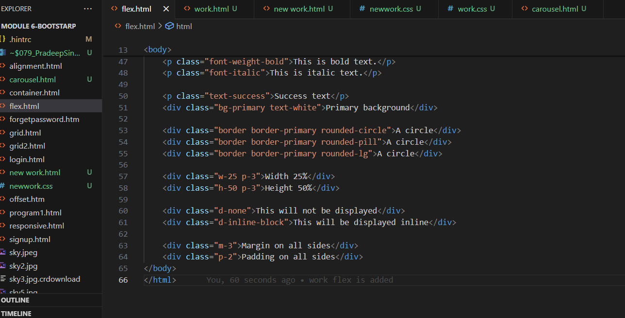

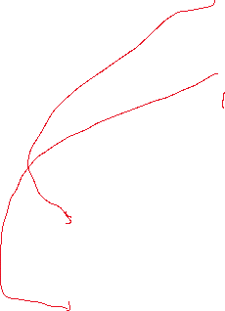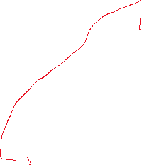

For above code below is the output:

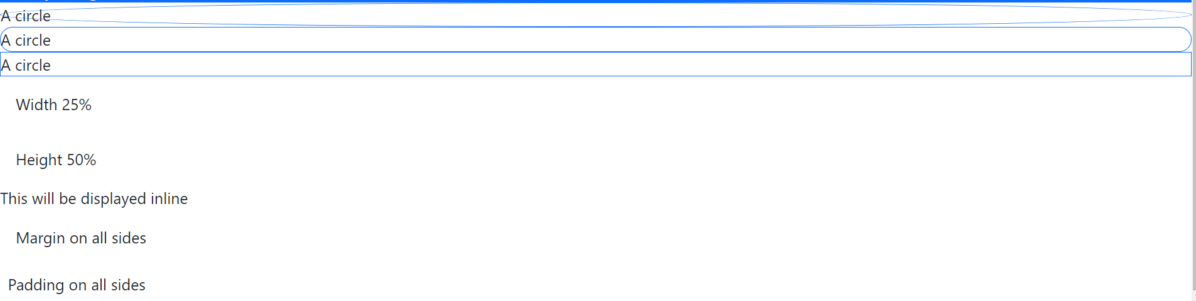

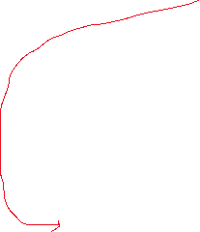

11. Sizing - Height and Width: Bootstrap provides classes to control the width and height of elements. You can use .w-25, .w-50, .w-75, .w-100 to control width (as a percentage of the parent element), and .h-25, .h-50, .h-75, .h-100 to control height. There’s also .mw-100 to limit the max-width to 100%.

12. Display: Bootstrap provides classes to control the CSS display property of elements. You can use .d-none (display: none), .d-inline, .d-inline-block, .d-block, .d-table, .d-table-row, .d-table-cell, .d-flex, .d-inline-flex. To apply these only on certain screen sizes, append -sm, -md, -lg, -xl.

13Spacing - Margin and Padding: Bootstrap provides classes to control the margin and padding of elements. The classes are formed as m-{sides}-{size} for margins and p-{sides}-{size} for padding. {sides} can be t, b, l, r, x (both left and right), y (both top and bottom), or blank (all sides). {size} can be from 0 to 5.